Functionality
You can delete costing results that are no longer required from the database when you specify certain criteria. This function is called reorganization.

Scenario
You can delete cost estimates:-
- Future standard cost estimates
- Current standard cost estimates
- Previous standard cost estimates
- Cost estimates not in material master (cost estimates saved but not yet marked or released)
Wrong cost estimate, due to wrong price of raw materials or error in BOM & routing, can be deleted. Then new cost estimates can be calculated. Be careful not to delete ‘Current standard cost estimates’ if there is already transaction data for that month.

Requirements
A cost estimate can only be deleted if it is not locked.

Menu Path | Accounting → Controlling → Product Cost Controlling → Product Cost Planning → Environment → Material Costing → CKR1 - Delete Test Data
Transaction Code | CKR1

1. Double click on CKR1 - Delete Test Data.

Reorganization of Cost Estimates

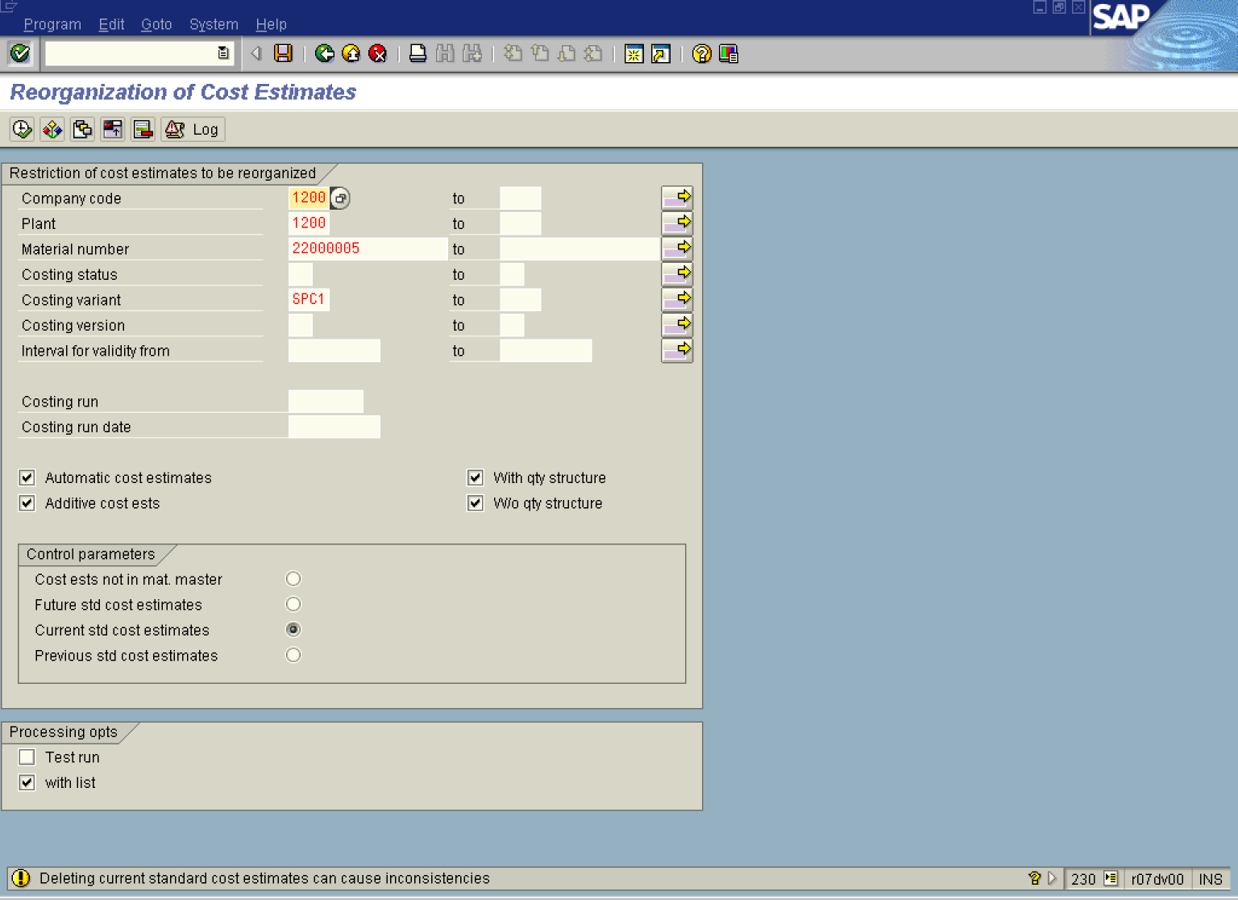

2. Click All selections button.
3. Update the following required and optional fields:

Field Name | Description | Values
Company code | Code identifying the company purchasing the material | Example: 1200
Plant | Code identifying the operational unit of the company where the material is manufactured and stored | Example: 1200
Material number | Code identifying a material | Example: 22000005
Costing variant | Description of the Costing variant. | Example: SPC1

4. Click the Current standard cost estimates radio button.
5. Click the Test run checkbox to deselect.

6. Click the Execute button.

7. Click the Enter button to proceed further with the deletion run after the system message.

Reorganization

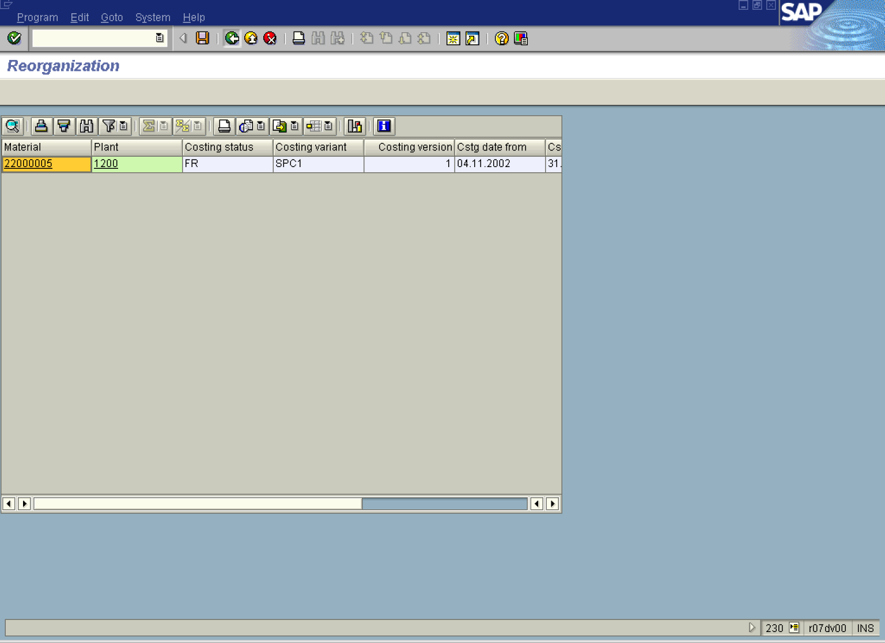

Note: If you delete a current standard cost estimate, the fields for the cost estimate are set to zero in the material master record. If you use the material ledger, the standard prices in the material ledger master data are also deleted when you delete the current standard cost estimate. The material master record for the material thus does no longer contains a current standard price from a standard cost estimate.

8. Click the Back button.

Reorganization of Cost Estimates

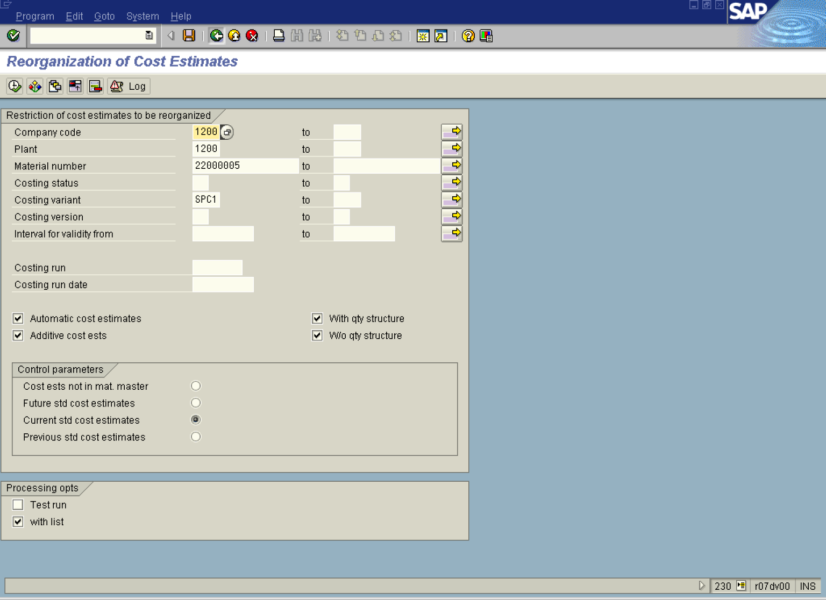

9. Click the Back button to go back to SAP Easy Access screen.

